**Batch: B-1 Roll No.: 16010122104**

**Experiment / assignment / tutorial No. 5**

TITLE : Implementation of IEEE-754 floating point representation

**AIM :** To demonstrate the single and double precision formats to represent floating point numbers.

______________________________________________________________________

**Expected OUTCOME of Experiment: (Mention CO/CO’s attained here)**

________________________________________________

Books/ Journals/ Websites referred:

1. Carl Hamacher, Zvonko Vranesic and Safwat Zaky, “Computer Organization”, Fifth Edition, TataMcGraw-Hill.
2. William Stallings, “Computer Organization and Architecture: Designing for Performance”, Eighth Edition, Pearson.

3. Dr. M. Usha, T. S. Srikanth, “Computer System Architecture and Organization”, First Edition, Wiley-India.

_____________________________________________________________________

**Pre Lab/ Prior Concepts:**

The IEEE Standard for Floating-Point Arithmetic (IEEE 754) is a technical

standard for floating-point computation established in 1985 by the Institute of Electrical

and Electronics Engineers (IEEE). The standard addressed many problems found in the

diverse floating point implementations that made them difficult to use reliably

and portably. Many hardware floating point units now use the IEEE 754 standard.

The standard defines: ● arithmetic formats: sets of binary and decimal floating-point data, which consist

of finite numbers (including signed zeros and subnormal numbers), infinities, and

special "not a number" values (NaNs) ● interchange formats: encodings (bit strings) that may be used to exchange

floating-point data in an efficient and compact form

● rounding rules: properties to be satisfied when rounding numbers during

arithmetic and conversions ● operations: arithmetic and other operations (such as trigonometric functions) on

arithmetic formats ● exception handling: indications of exceptional conditions (such as division by zero, overflow, etc.

**Example (Single Precision- 32 bit representation )**

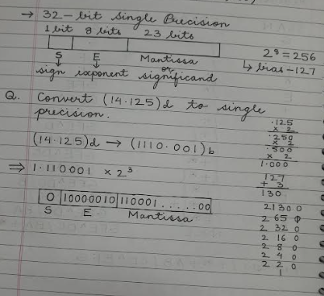

**Example (Double Precision- 64 bit representation )**

**Post Lab Descriptive Questions**

**Give the importance of IEEE-754 representation for floating point numbers?**

**Ans:**

IEEE-754 is vital due to its standardized and accurate representation of floating-point numbers. It ensures compatibility, precision, and error control across diverse computing systems and applications, promoting portability and reliability. This standard supports both single and double precision, making it suitable for a wide range of numeric values. IEEE-754 is particularly crucial in scientific, engineering, and graphics applications and benefits from hardware support in modern computer systems, enhancing computational efficiency.

**Conclusion:**

We learned to demonstrate the single and double precision formats to represent floating point numbers.

**Date: 06/08/2023**